**Redial**

**Speaker**

**Call Forwarding**

**Phonebook**

**Voicemail**

**Conference**

**Caller List**

**Callback**

**Pick Up**

**Speed Dial 8**

**Speed Dial 7**

**Speed Dial 6**

**Speed Dial 5**

**Speed Dial 4**

**Speed Dial 3**

**Speed Dial 2**

**Speed Dial 1**

**Line 2**

**Line 1**

**Speaker**

**Redial**

**Call Transfer**

**Call Forwarding**

**Speed Dial 2**

**Speed Dial 6**

**Speed Dial 3**

**Speed Dial 5**

**Speed Dial 2**

**Speed Dial 4**

**Speed Dial 1**

**Line 1**

**Redial**

**Call Transfer**

**Voicemail**

**Call Forwarding**

**Speed Dial 1**

**Line 2**

**Line 1**

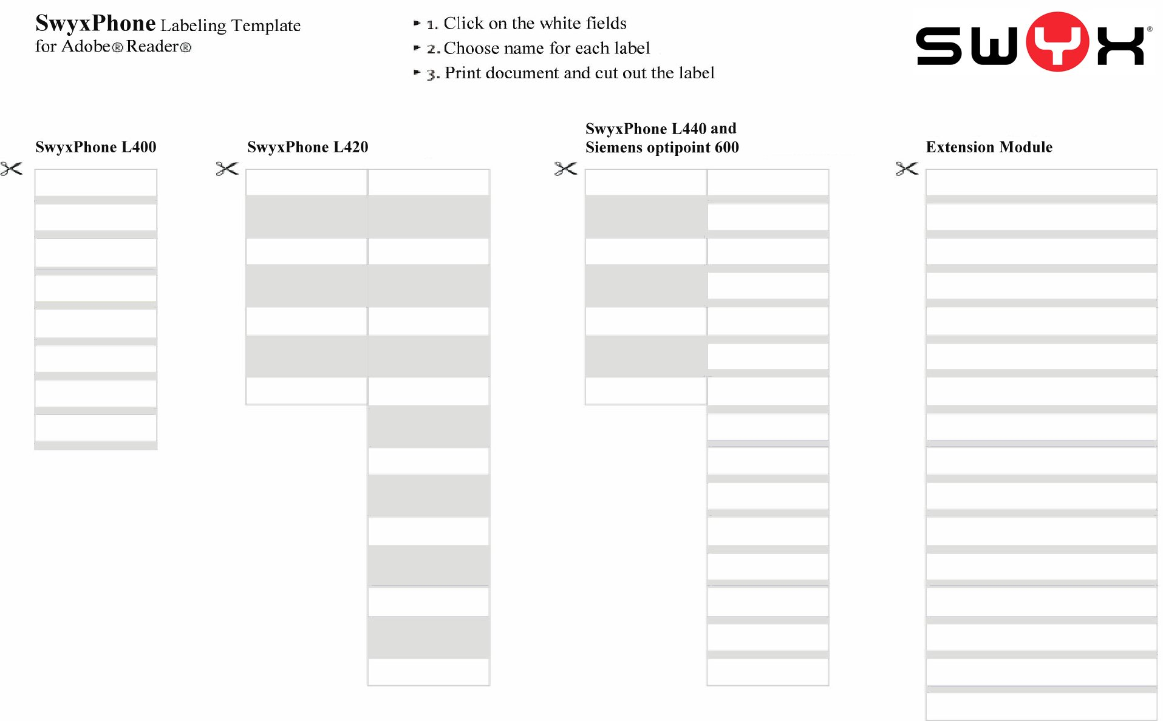

Line 1

Speed Dial 1

Speed Dial 2

Speed Dial 3

Callback

Pick Up

Line 2

Line 1

Speed Dial 2

Speed Dial 4

Speed Dial 6

Speed Dial 8

Conference

Phonebook

Speed Dial 1

Speed Dial 3

Speed Dial 5

Speed Dial 7

Caller List

Voicemail

Voicemail

Redial

Speed Dial 2

Line 2

Call Forwarding

Call Transfer

Speed Dial 1

Line 1

