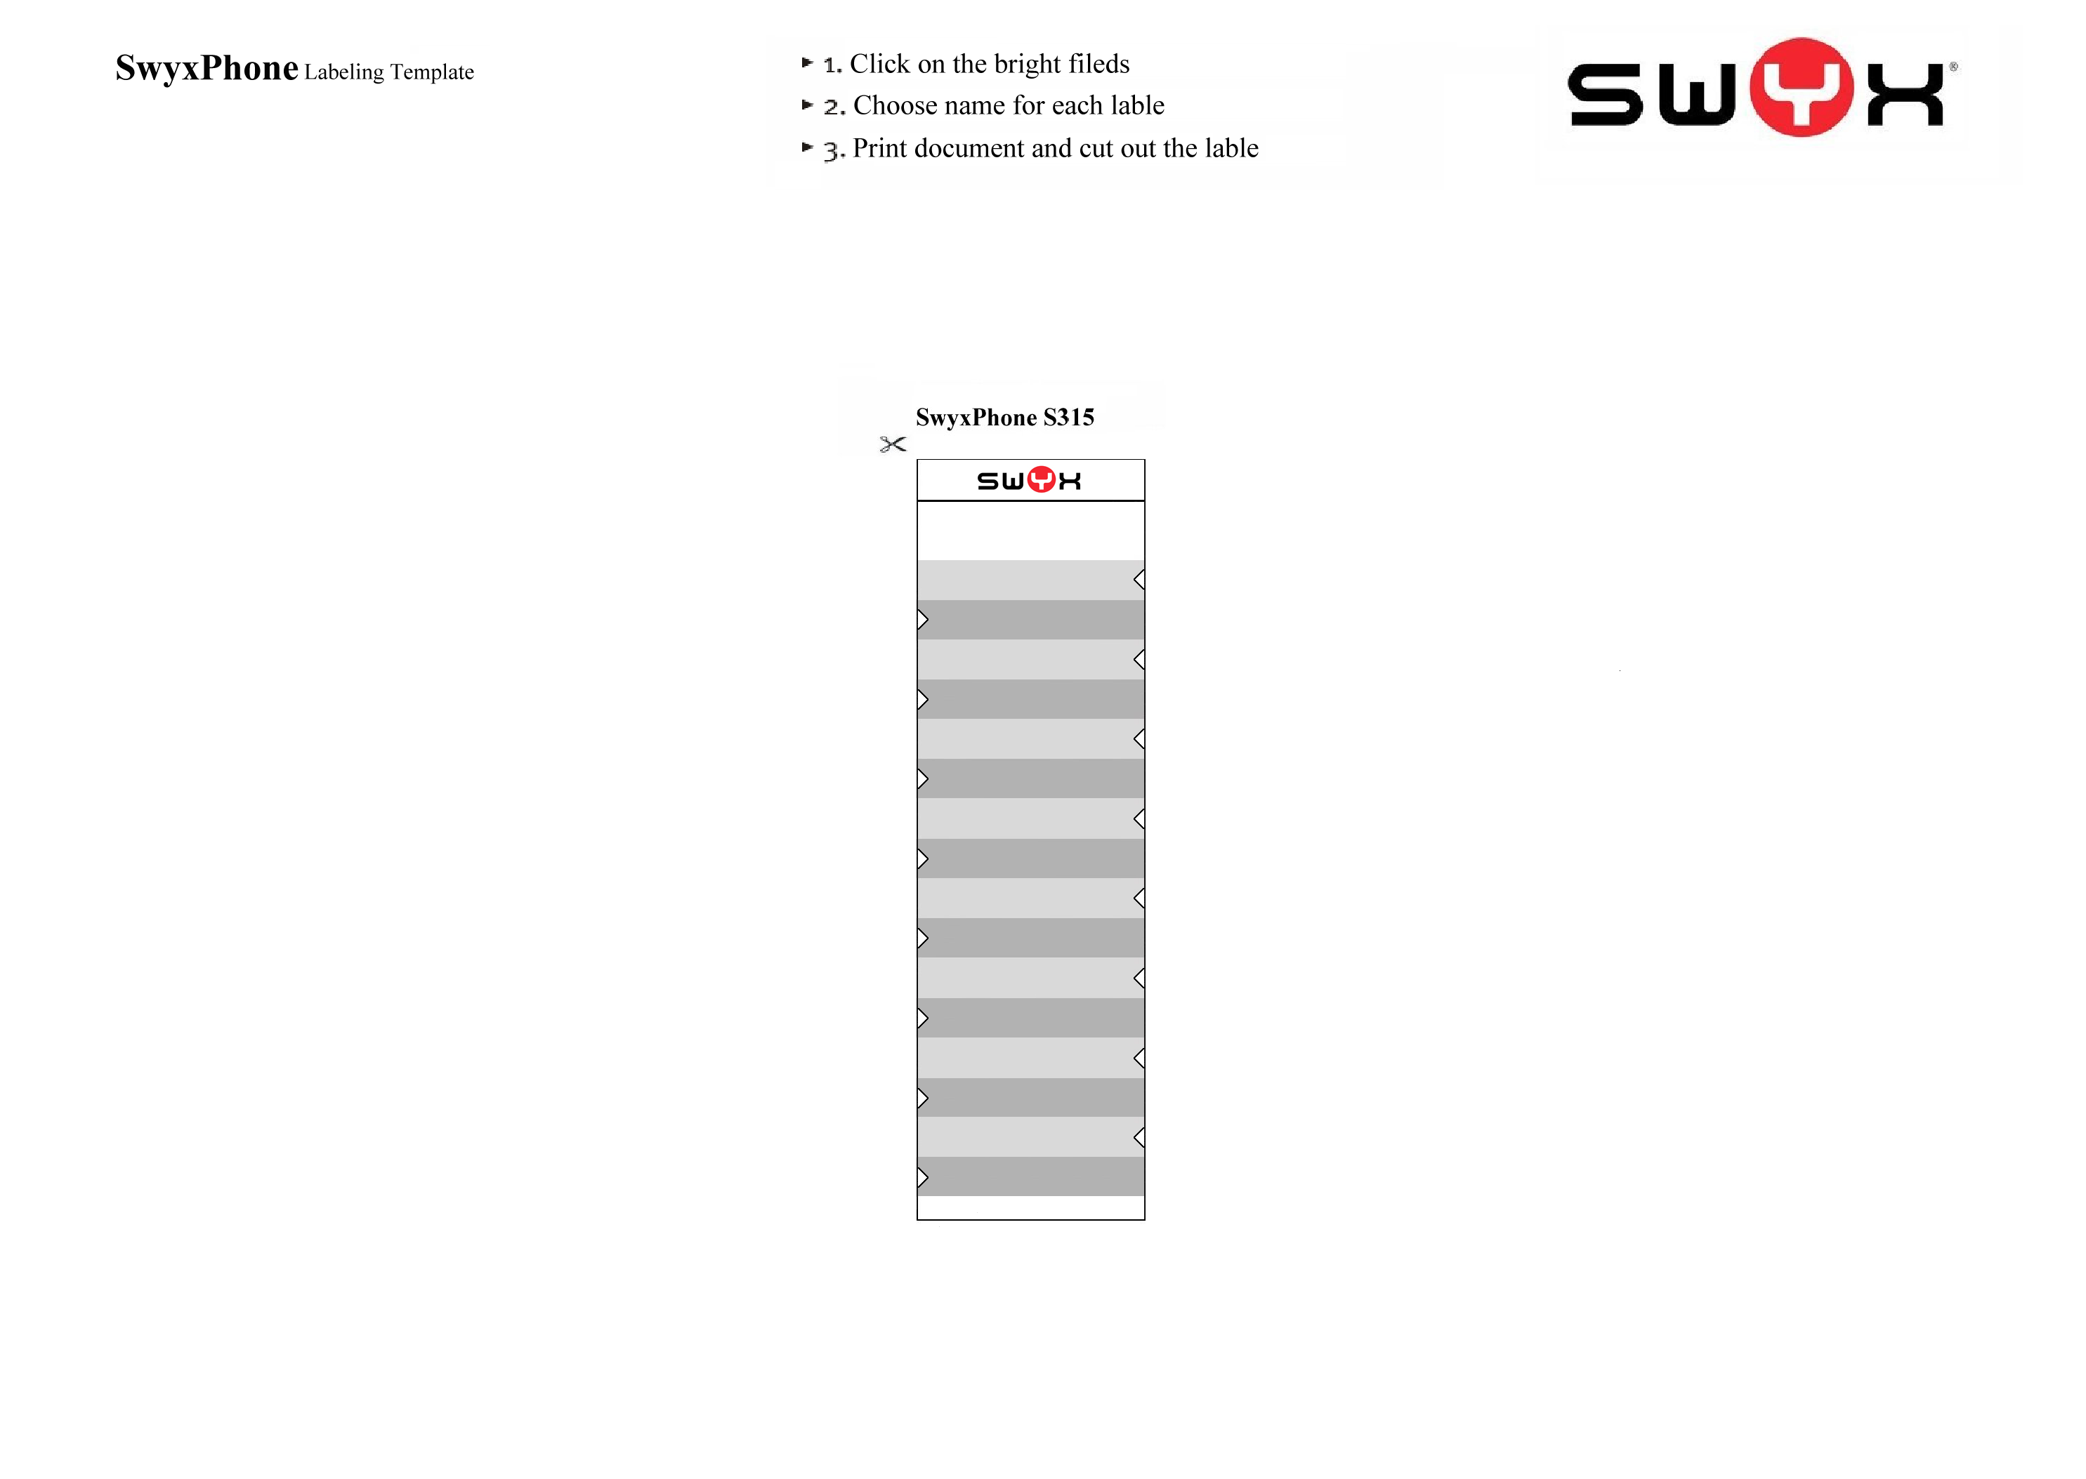

Mute

Headset

Voicemail

Pick Up

Conference

Transfer

Hold/Call Swap

Missed calls

Do not Disturb